ACADEMIC SENATE
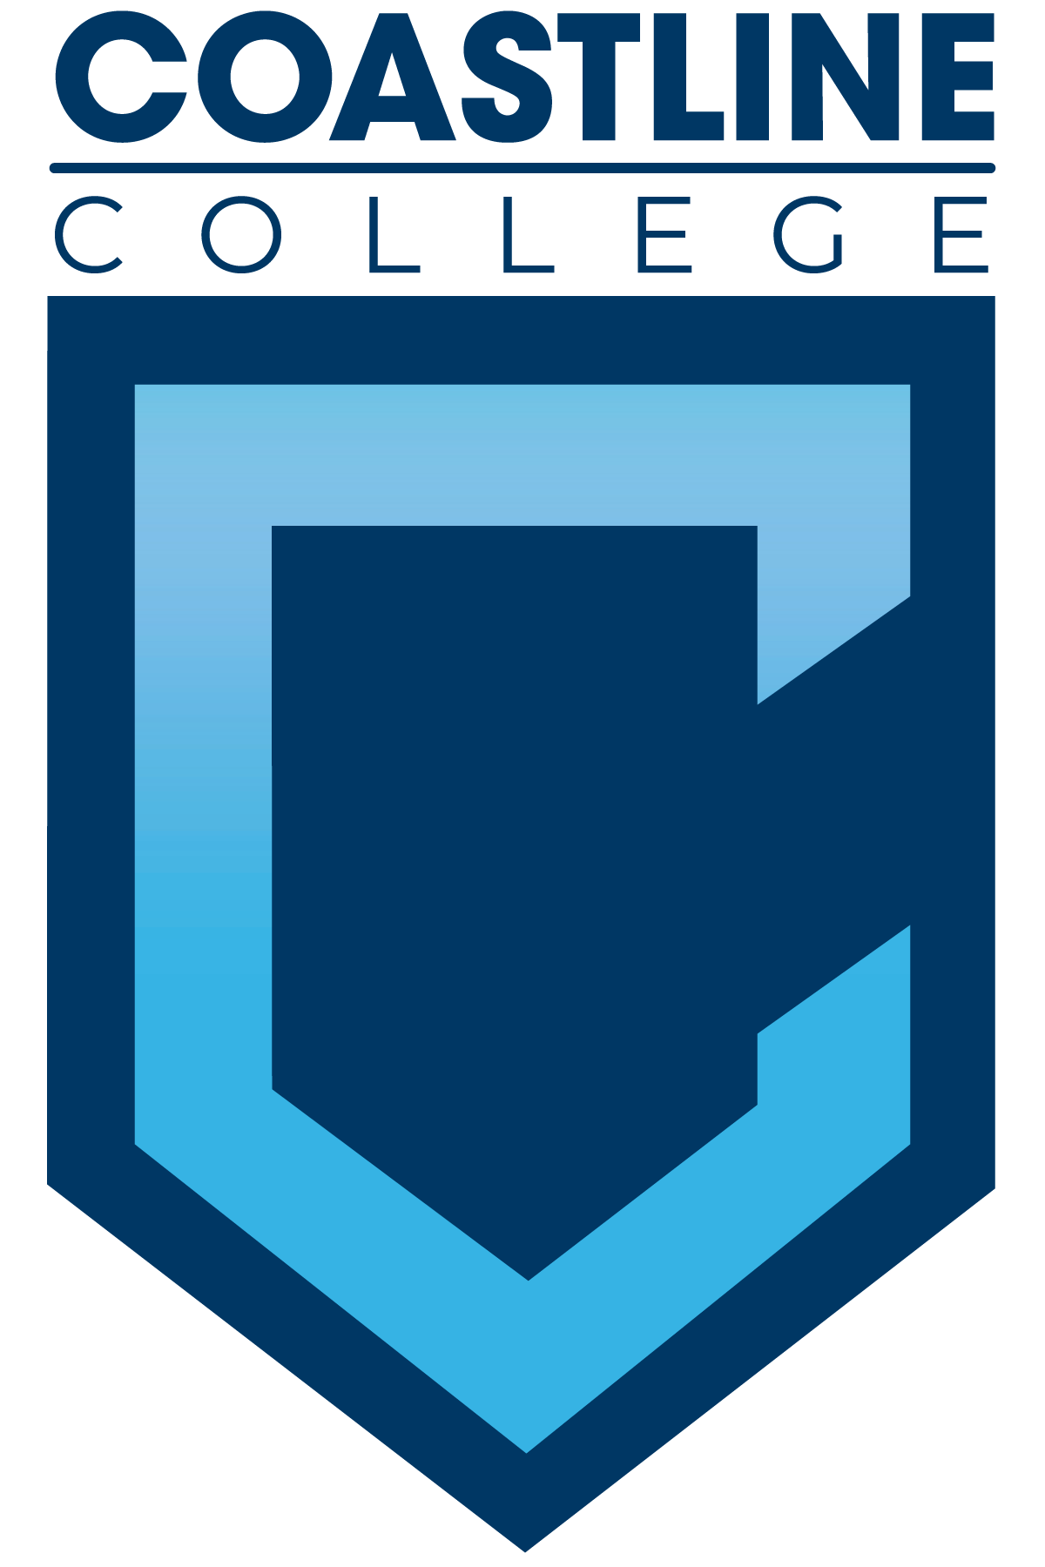

February 16, 2021 12:30 p.m.– 2:30 p.m.
Via ZOOM or
Call in: 1 (669) 900-6833, Meeting ID: 97867035113#
AGENDA

College Mission Statement: Coastline College guides diverse populations of students toward the attainment of associate degrees and certificates leading to career advancement, personal empowerment, and transfer. By meeting students where they are, Coastline provides innovative instruction and services designed to achieve equitable outcomes.

12:30 p.m. PRELIMINARY

- CALL TO ORDER: President Deborah Henry
  - Pledge of Allegiance
  - Roll Call
  - Adopt Agenda
  - **Approval of Minutes 02/02/2021
  - Consent Calendar:
  - Public Comment and Statement: Members of the public have the opportunity to address the Academic Senators on any item that has been described in this notice, before or during consideration of the item. Persons wishing to make comments are allowed three minutes.

REPORTS
  - Executive Committee Reports (1-2 minutes each)
    - President – D. Henry: Plenary April 15-17; The Best We Could Do
    - Treasurer’s Report –
    - Other Executive Committee Member Reports
  - Senate Committee Reports (1-2 minutes each)
    - Academic Rank: Tobi West
    - Academic Standards: Ann Holliday
    - Budget and Finance: Ann Holliday
    - Faculty Recognition: Ann Holliday
    - Communications: David Lee
    - Elections: David Lee
    - Social: David Lee
    - Professional Development Institute: Lisa Lee
    - Policy and Procedures/Participatory Governance: Lisa Lee /Ann Holliday
    - Department Chairs: Lisa Lee
    - Curriculum: Dan Johnson
    - Program Review: Brandon Brown
    - Faculty Professional Development and Leadership Committee: Stephen Barnes
    - Academic Quality Rubric/Syllabus Task Force: Josh Levenshus
    - Respondus Task Force: Tobi West

Coordinator Reports (1-2 minutes each)
    - Coastline Pathways Coordinator: Josh Levenshus
    - FC Coordinator: Stephen Barnes
    - SLO Coordinators: Steve Fauce, Brandon Brown
    - OER Coordinator: Elizabeth Horan
    - Student Success Coordinator: Danny Pittaway
    - Faculty Accreditation Coordinator: Marilyn Brock
    - Flex Coordinator: Ann Holliday
  - Vice President Reports (2 minutes each)
    - Vince Rodriguez
    - Kate Mueller
    - Christine Nguyen
  - ASG Representative –
  - Classified Representative – Helen Ward
- COLLEGE COMMITTEE REPORTS (1-2 minutes each)
  - College Professional Development and Leadership: David Lee
  - Facilities, Safety, & Sustainability: Angela Gomez-Holbrook
  - Budget: Deborah Henry
  - College Council: Deborah Henry
  - PIEAC: Lisa Lee
  - Technology: Cheryl Chapman
- STRETCH
- SPECIAL REPORTS
- ACTION ITEMS
  - **Endorsement/Approval of the SOAA Guided Pathways report
- DISCUSSION ITEMS
  - Faculty Equity Champions-Equity Canvas Course – Erin Thomas
  - RSI – Dan Johnson
  - Fall schedule and pandemic fatigue – D. Henry
  - **Bylaws – Lisa Lee; Ann Holliday
  - HEDS survey – Stephen Barnes
  - **Golden West Academic Senate Resolution – D. Henry
  - **Committee restructuring – D. Henry
- ANNOUNCEMENTS (1-minute limit)
- ADJOURNMENT
**Copies have been sent to Senators. Others who would like a copy should contact the Senate office at academicsenate@coastline.edu

Contact the Senate Office ~~ We welcome your input!
Deborah Henry ~~ Email: academicsenate@coastline.edu or dhenry@coastline.edu
Academic Senate Webpage

